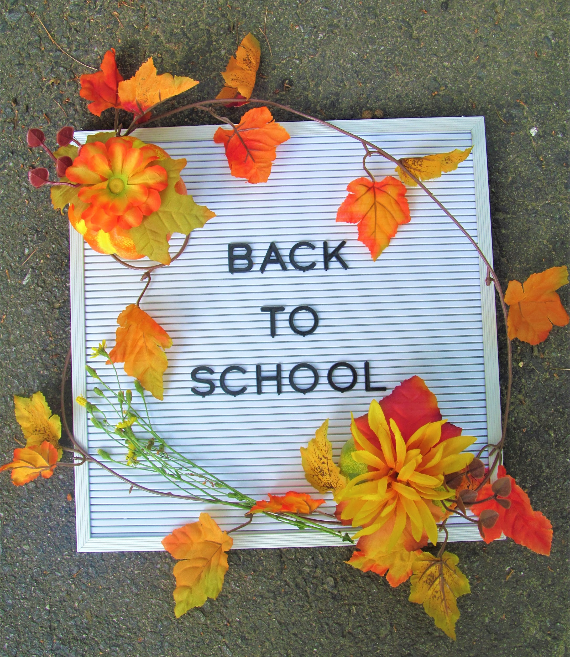
School Week Devotional
By-Cait Winters

The dog days of summer have come to an end and the cool autumn winds carry with them with them a new school year. Whether we homeschool or send our kiddos on their way each day, households with school aged kids have to adjust and settle back into the school year routine.

I think parents and kids alike could use some encouragement to help us ease into the new academic year confidently and prayerfully. I hope that this 5 day mini-devotional will help you to do just that!

Start this devotional on a Monday. Make sure that the Sunday before you go to church and carve out some quiet time with God. Pray over your child(ren), the academic year ahead, yourself, their school and their teachers. Ask that the holy spirit be with you when you read this devotional and that your heart be open to receive the wisdom and peace God offers you through his promises and through his word.

I know it can be tough in the hustle and bustle but, try to get up 5 minutes early, pray, and use this devotional in the morning. I made these passages and reflections bite-sized for all my fellow Mamas on the go! I also included some reminders and conversation starters to use with your kids. A snippet of scripture and a prayer is a great way to start the day!
God Bless You,
💗Cait

Monday

He will cover you with his feathers, and under his wings you will find refuge; his faithfulness will be your shield and rampart.

For he will command his angels concerning you to guard you in all your ways; they will lift you up in their hands, so that you will not strike your foot against a stone.
~Psalm 91 Chapters 4 & 11-12

It’s Monday morning, Mama! I don’t know about you but for me, Mondays are tough. Not only is everyone a bit sluggish (including myself) but, I miss my oldest when she’s at school. I have to send her on the bus, out from the comfort of our home into an environment over which I have much less control.

Though I feel she is safe and taken care of at her school I still get a bit of anxiety on the first day when she climbs on the bus and goes out into her world of peers, classes, and sports. I feel a whole lot better when I read the verses above and remember that God sends his angels out into the world to guide and guard his people.

Remind your child that God is there as a refuge and a resource for them. Pray and ask the Lord to send his holy spirit and his heavenly helpers to be close to your children each day and to guide them back home safely.

Tuesday

Don’t let anyone look down on you because you are young, but set an example for the believers in speech, in conduct, in love, in faith and in purity. 1 Timothy 4:12

So Monday’s down and you and your tribe are settling into the weekly rhythm. Check in with your kids today and ask about their relationships at school. I always remind my daughter of the importance of kindness. That you never know the circumstances of the lives of their fellow students or even the teachers.

My school aged child is in 6th grade this year and friends and social status are of the utmost importance. Give your kids the opportunity to seek advice if needed, ask if they are making new friends and getting along with teachers. Offer understanding and prayer.

Remind them of how many people work to give them a good school experience, from the principal who oversees operations to the janitors who make sure their environment is clean and healthy. Or maybe it’s a parent or a tutor making lesson plans and teaching.

Remind them to set a standard of respect for others and to say please and thank you. That growing up is sometimes hard for others too and to be empathetic towards their peers. That the world doesn’t need another negative person but more people who love like Jesus.

Wednesday

Therefore put on the full armor of God...Stand firm then, with the belt of truth buckled around your waist, with the breastplate of righteousness in place, and with your feet fitted with the readiness that comes from the gospel of peace.
In addition to all this, take up the shield of faith, with which you can extinguish all the flaming arrows of the evil one.
Take the helmet of salvation and the sword of the Spirit, which is the word of God. ~Ephesians 6:13-17

Hey, Mama! Are you and your youngsters hitting that mid-week slump? Here’s a little motivation for us all to move into the second half of the week with confidence!

Read the above passage to your child before bed and have fun with it! Act out the putting on of the belt, breastplate, helmet and other items. Discuss how each item (righteousness, readiness ect..) can help them face the day. Remind them (and yourself) to put on the full armor of God each morning.

Thursday

All your children shall be taught by the Lord,
And great shall be the peace of your children. ~Isaiah 54:13

It’s Thursday, arguably one of my favorite weekdays! Though it’s usually a full day for us with extracurricular activities after school, the weekend is in sight. Feeling like we’re hitting the last mile gives me a burst of energy to finish the week strong!

God doesn’t want our experience with him to be confined to the walls of a church, as Christians, we should seek to encounter God everywhere. Remind your kids to pay attention not only to the lessons their teachers are trying to teach but also to the lessons that God may be trying to teach them through their experiences at school.
Maybe they are getting a lesson in perseverance by studying hard for an important test or they get the opportunity to stand up for what is right. Remind them that God is not separate from their “real life” but present in every facet of their lives.

Friday

Yet you, Lord, are our Father.
We are the clay, you are the potter;
we are all the work of your hand. ~Isaiah 64:8

It’s Fri-YAY! I don’t know about you but the weekend is the life for me! I love the rest, relaxation, and togetherness after a busy week with my family running in all directions.

Though weekends offer much needed R&R, we know that to grow, spiritually and academically we need to be pushed outside of our comfort zones on a regular basis. Learning naturally comes some trial and error. Eventually your student will probably struggle some along the way. When you’re molding clay you don’t just touch it once to form its shape, you apply consistent pressure and with patient effort a masterpiece is made! Whether it’s a subject they aren’t quite masterting yet or the loss of a game or competition, remind your child that they are still a work in progress and to hold their head high as they are molded into the unique people that God created them to be!

Congratulations! You’ve completed the week and this devotional, I hope it helped to encourage you and your kids! Reward yourself and your family this weekend, you deserve it! Thank you for praying through your week with me. Hold on to these promises of the Lord and carry them with you until the summer days are here again!

God Bless,
💗Cait

